EWMA correlation: NZDUSD and USDJPY
Method 06 / daily log returns / lambda = 0.94 / Alpari D1 full available history

Study setup
Logical pair: NZDUSD , USDJPY
Broker symbols: NZDUSD_i , USDJPY_i
Snapshot: 2026-11-03_majors_alpari_D1
Timeframe: D1
Matched return window: 1999-01-05 to 2026-11-02 (UTC bar dates)
Matched return count n: 7185
Dropped unfinished last bar dated 2026-11-03 UTC after a tick-volume check against the prior complete day.
Lambda: 0.94 (today weight 0.06)
Burn-in ignored in path summaries and chart: first 60 updates
Mean adjustment: each leg demeaned by its mean on the matched rows
Seeds: c_0 = v_x,0 = v_y,0 = 0
Complete matched rows (Excel): NZDUSD-USDJPY_EWMA_D1.xlsx
Complete matched rows (HTML table): NZDUSD-USDJPY_EWMA_D1_data.html

Method carried forward
EWMA correlation updates covariance and variances of mean-adjusted daily log returns of close, ln(close_t / close_t-1), with lambda = 0.94 (6% weight on today's product or square, 94% on yesterday's EWMA state). Quotes are not inverted. Each leg is demeaned by its mean on the matched rows; that mean uses the full sample, so the rho path is a full-sample description, not a live filter. Seeds start at zero. Path summaries and the chart ignore the first 60 updates so the zero seed has faded. The headline is rho on the last day. rho is symmetric under swap of the two symbols. A high |rho| does not prove cause, lead-lag, or a trading signal. Today's return sits inside today's rho, so the estimate can only inform a later decision. Same-sample Pearson r is a side check only.

Results
Latest EWMA rho: -0.239394
Post-burn-in path (n=7125): mean=-0.247805, median=-0.301040, min=-0.827228, max=0.901342, std=0.321541
Share of post-burn-in days with |rho| >= 0.4: 41.05%; |rho| >= 0.7: 4.06%
Same-sample Pearson r: -0.133568
Latest rho minus r: -0.105826

Conclusion
Over 7185 matched daily log-return rows for NZDUSD and USDJPY (broker quote directions unchanged), latest EWMA rho with lambda=0.94 is -0.2394 (negative, weak recent linear link in this sample). After a 60-day burn-in, path mean is -0.2478, std is 0.3215, and the range is [-0.8272, 0.9013]. Same-sample Pearson r is -0.1336 (latest rho minus r = -0.1058). This does not establish cause, lead-lag, or a lasting trading rule.

Charts
Daily closes

Daily log returns
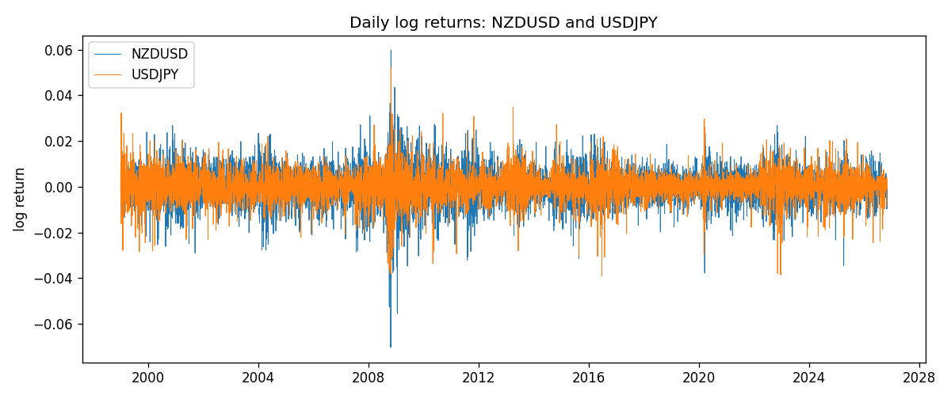
EWMA rho path with Pearson r reference
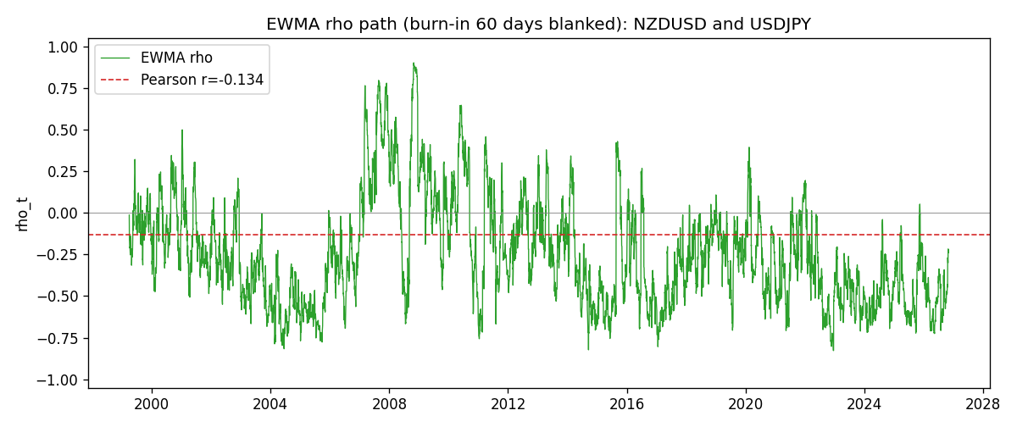

Data report
Every matched row that entered the EWMA recursion is stored in the sibling Excel workbook named NZDUSD-USDJPY_EWMA_D1.xlsx. That file is the complete data archive for redrawing charts. Embedding all rows as a Word table is impractical at this length; the Word file holds the column list, column summaries, and the first and last 15 matched rows.
Columns: time, NZDUSD_open, USDJPY_open, NZDUSD_high, USDJPY_high, NZDUSD_low, USDJPY_low, NZDUSD_close, USDJPY_close, NZDUSD_tick_volume, USDJPY_tick_volume, NZDUSD_spread, USDJPY_spread, NZDUSD_real_volume, USDJPY_real_volume, NZDUSD_log_return, USDJPY_log_return, NZDUSD_x_demeaned, USDJPY_y_demeaned, c_t, v_x, v_y, rho_t
Column summaries (matched calculation rows)
column | count | mean | std | min | 25% | 50% | 75% | max
NZDUSD_open | 7185 | 0.65641035 | 0.10820414 | 0.3913 | 0.59133 | 0.6684 | 0.72491 | 0.88218
USDJPY_open | 7185 | 113.80829 | 19.224285 | 75.693 | 104.39 | 110.98 | 120.695 | 163.824
NZDUSD_high | 7185 | 0.6603272 | 0.1086977 | 0.3961 | 0.59474 | 0.672 | 0.72936 | 0.88421
USDJPY_high | 7185 | 114.30556 | 19.28576 | 76.001 | 104.868 | 111.439 | 121.26 | 163.978
NZDUSD_low | 7185 | 0.65272421 | 0.10779902 | 0.3897 | 0.58806 | 0.66417 | 0.72098 | 0.87988
USDJPY_low | 7185 | 113.28523 | 19.152023 | 75.402 | 103.88 | 110.53 | 120.17 | 163.628
NZDUSD_close | 7185 | 0.65648647 | 0.10820164 | 0.3907 | 0.59157 | 0.6684 | 0.72502 | 0.8822
USDJPY_close | 7185 | 113.8211 | 19.239467 | 75.811 | 104.38 | 111.015 | 120.69 | 163.851
NZDUSD_tick_volume | 7185 | 68717.699 | 123140.61 | 16 | 5585 | 33899 | 58511 | 1127682
USDJPY_tick_volume | 7185 | 106344.18 | 179438.14 | 149 | 9948 | 53202 | 92889 | 1803508
NZDUSD_spread | 7185 | 30.280167 | 25.649381 | 0 | 9 | 17 | 40 | 80
USDJPY_spread | 7185 | 20.273626 | 17.623751 | 0 | 6 | 11 | 30 | 50
NZDUSD_real_volume | 7185 | 1.6703703e+10 | 8.4983725e+10 | 0 | 0 | 0 | 0 | 2.705649e+12
USDJPY_real_volume | 7185 | 3.4781051e+10 | 1.6093614e+11 | 0 | 0 | 0 | 0 | 3.8834203e+12
NZDUSD_log_return | 7185 | 1.284e-05 | 0.0076404 | -0.07027433 | -0.00425236 | 0.00022967 | 0.00458145 | 0.05966839
USDJPY_log_return | 7185 | 4.789e-05 | 0.00620418 | -0.03908203 | -0.00320044 | 0.00011802 | 0.00340223 | 0.05184024
NZDUSD_x_demeaned | 7185 | 0 | 0.0076404 | -0.07028718 | -0.0042652 | 0.00021682 | 0.00456861 | 0.05965555
USDJPY_y_demeaned | 7185 | 0 | 0.00620418 | -0.03912992 | -0.00324833 | 7.013e-05 | 0.00335434 | 0.05179235
c_t | 7185 | -6.32e-06 | 3.302e-05 | -0.00010719 | -1.761e-05 | -8.64e-06 | -1.69e-06 | 0.00053756
v_x | 7185 | 5.833e-05 | 5.891e-05 | 2.1e-07 | 3.052e-05 | 4.238e-05 | 6.676e-05 | 0.00086274
v_y | 7185 | 3.846e-05 | 3.193e-05 | 0 | 1.896e-05 | 3.09e-05 | 4.769e-05 | 0.00041229
rho_t | 7185 | -0.24761725 | 0.32178561 | -0.83969324 | -0.49422308 | -0.30035657 | -0.05864709 | 1
First 15 matched rows (selected columns)
time | NZDUSD_close | USDJPY_close | NZDUSD_log_return | USDJPY_log_return | NZDUSD_x_demeaned | USDJPY_y_demeaned | c_t | v_x | v_y | rho_t
1999-01-05 | 0.5372 | 111.92 | -0.0018597736 | -0.00017868311 | -0.0018726181 | -0.00022657514 | 2.5457322e-08 | 2.1040191e-07 | 3.0801777e-09 | 1
1999-01-06 | 0.5383 | 112.77 | 0.0020455609 | 0.0075660159 | 0.0020327165 | 0.0075181239 | 9.4086274e-07 | 4.4569397e-07 | 3.3942265e-06 | 0.7649578
1999-01-07 | 0.5417 | 111.33 | 0.0062963171 | -0.012851583 | 0.0062834727 | -0.012899475 | -3.9787988e-06 | 2.7878741e-06 | 1.317436e-05 | -0.65652405
1999-01-08 | 0.5414 | 110.8 | -0.00055396548 | -0.0047719894 | -0.00056680992 | -0.0048198815 | -3.5761534e-06 | 2.639878e-06 | 1.3777773e-05 | -0.59297269
1999-01-11 | 0.547 | 109.02 | 0.010290425 | -0.016195423 | 0.010277581 | -0.016243315 | -1.3378103e-05 | 8.8192054e-06 | 2.8781823e-05 | -0.83969324
1999-01-12 | 0.5441 | 112.6 | -0.0053157489 | 0.032310364 | -0.0053285934 | 0.032262472 | -2.2890232e-05 | 9.9936875e-06 | 8.950694e-05 | -0.76534803
1999-01-13 | 0.5387 | 113.52 | -0.0099742238 | 0.0081373171 | -0.0099870682 | 0.0080894251 | -2.6364197e-05 | 1.5378558e-05 | 8.8062852e-05 | -0.7164079
1999-01-14 | 0.5386 | 113.52 | -0.00018564931 | 0 | -0.00019849375 | -4.7892036e-05 | -2.4781775e-05 | 1.4458209e-05 | 8.2779218e-05 | -0.71633225
1999-01-15 | 0.5382 | 114.15 | -0.00074294208 | 0.0055343401 | -0.00075578652 | 0.0054864481 | -2.3543663e-05 | 1.3624989e-05 | 7.9618532e-05 | -0.71482359
1999-01-18 | 0.5372 | 114.16 | -0.0018597736 | 8.7600193e-05 | -0.0018726181 | 3.9708157e-05 | -2.2135505e-05 | 1.3017892e-05 | 7.4841514e-05 | -0.70916587
1999-01-19 | 0.5382 | 113.52 | 0.0018597736 | -0.0056219403 | 0.0018469292 | -0.0056698324 | -2.1435681e-05 | 1.2441487e-05 | 7.2279844e-05 | -0.71481318
1999-01-20 | 0.5404 | 112.91 | 0.0040793678 | -0.0053879917 | 0.0040665234 | -0.0054358837 | -2.1475849e-05 | 1.2687194e-05 | 6.9715983e-05 | -0.7221067
1999-01-21 | 0.5426 | 113.87 | 0.0040627941 | 0.0084664056 | 0.0040499497 | 0.0084185136 | -1.8141625e-05 | 1.2910088e-05 | 6.9785306e-05 | -0.60440714
1999-01-22 | 0.5361 | 114.56 | -0.012051689 | 0.0060412564 | -0.012064534 | 0.0059933644 | -2.1391556e-05 | 2.0868662e-05 | 6.7753413e-05 | -0.56889157
1999-01-25 | 0.5342 | 113.72 | -0.0035504102 | -0.0073594164 | -0.0035632546 | -0.0074073085 | -1.8524415e-05 | 2.0378349e-05 | 6.6980301e-05 | -0.50140247
Last 15 matched rows (selected columns)
time | NZDUSD_close | USDJPY_close | NZDUSD_log_return | USDJPY_log_return | NZDUSD_x_demeaned | USDJPY_y_demeaned | c_t | v_x | v_y | rho_t
2026-10-13 | 0.56127 | 158.305 | 0.0047326165 | -0.0018932826 | 0.0047197721 | -0.0019411746 | -8.9398173e-06 | 1.6972277e-05 | 1.9770217e-05 | -0.48803713
2026-10-14 | 0.55918 | 158.317 | -0.0037306483 | 7.5800166e-05 | -0.0037434927 | 2.790813e-05 | -8.4096967e-06 | 1.6794765e-05 | 1.8584051e-05 | -0.47601778
2026-10-15 | 0.56185 | 158.024 | 0.0047634855 | -0.0018524319 | 0.004750641 | -0.001900324 | -8.4467803e-06 | 1.7141194e-05 | 1.7685682e-05 | -0.48513182
2026-10-16 | 0.56509 | 157.964 | 0.0057501001 | -0.00037976126 | 0.0057372557 | -0.0004276533 | -8.0871868e-06 | 1.8087689e-05 | 1.6635514e-05 | -0.4662167
2026-10-19 | 0.56616 | 158.517 | 0.0018917133 | 0.0034946841 | 0.0018788688 | 0.0034467921 | -7.2133914e-06 | 1.7214236e-05 | 1.6350206e-05 | -0.4299659
2026-10-20 | 0.56827 | 158.16 | 0.0037199341 | -0.0022546642 | 0.0037070897 | -0.0023025563 | -7.2927349e-06 | 1.7005933e-05 | 1.5687299e-05 | -0.44649449
2026-10-21 | 0.57003 | 158.108 | 0.0030923331 | -0.00032883504 | 0.0030794887 | -0.00037672708 | -6.9247784e-06 | 1.6554572e-05 | 1.4754577e-05 | -0.44308141
2026-10-22 | 0.56815 | 156.755 | -0.0033035227 | -0.0085942669 | -0.0033163671 | -0.0086421589 | -4.7896574e-06 | 1.6221195e-05 | 1.8350517e-05 | -0.27761241
2026-10-23 | 0.56991 | 156.81 | 0.0030929853 | 0.00035080446 | 0.0030801408 | 0.00030291243 | -4.4462972e-06 | 1.581716e-05 | 1.7254991e-05 | -0.26913915
2026-10-26 | 0.56826 | 157.458 | -0.0028993932 | 0.0041238746 | -0.0029122376 | 0.0040759826 | -4.8917331e-06 | 1.5376998e-05 | 1.721651e-05 | -0.30064531
2026-10-27 | 0.56811 | 157.894 | -0.00026399852 | 0.0027651658 | -0.00027684296 | 0.0027172737 | -4.6433646e-06 | 1.4458976e-05 | 1.6626534e-05 | -0.29947678
2026-10-28 | 0.56261 | 157.743 | -0.0097283914 | -0.00095679538 | -0.0097412359 | -0.0010046874 | -3.7775489e-06 | 1.9284938e-05 | 1.5689505e-05 | -0.21716826
2026-10-29 | 0.56296 | 157.683 | 0.00062190714 | -0.00038043789 | 0.0006090627 | -0.00042832992 | -3.5665488e-06 | 1.8150099e-05 | 1.4759143e-05 | -0.21791047
2026-10-30 | 0.56307 | 157.516 | 0.00019537668 | -0.0010596481 | 0.00018253224 | -0.0011075402 | -3.3646856e-06 | 1.7063093e-05 | 1.3947193e-05 | -0.21810831
2026-11-02 | 0.56161 | 157.933 | -0.0025962955 | 0.0026438521 | -0.00260914 | 0.00259596 | -3.5691978e-06 | 1.6447764e-05 | 1.3514702e-05 | -0.23939438

